Experiment 1.1.4 ) Area of Triangle

PRN 25070521167

A)Algorithm
1. Start
2. Read base (b) and height (h)
3. Compute area = 0.5 × b × h
4. Display/Print the area formatted to 2 decimal places
5. Stop

B)Flowchart
Flowchart diagram:
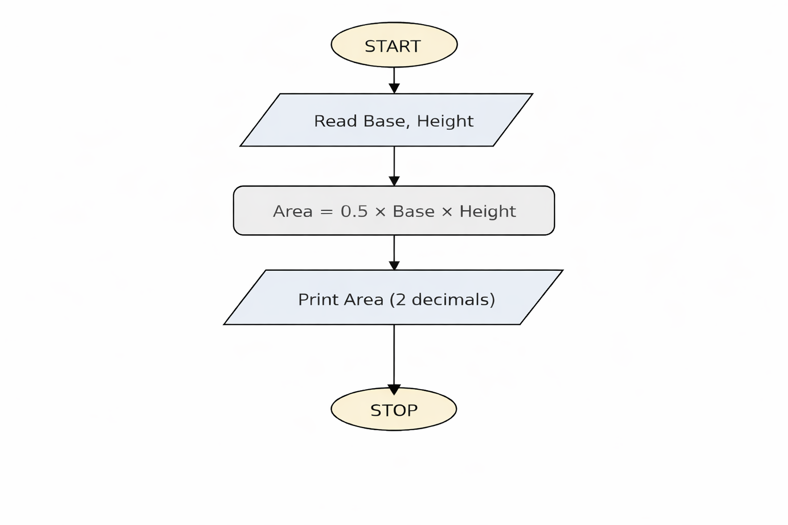

C) Python Code
base = float(input())
height = float(input())
area = 0.5 * base * height
print(f"{area:.2f}")

D) EXECUTION
